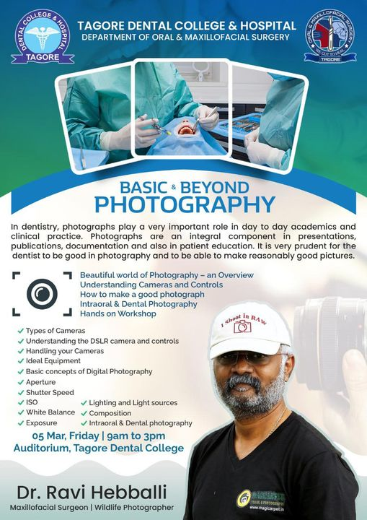

DEPARTMENT OF ORAL AND MAXILLOFACIAL SURGERY
TAGORE DENTAL COLLEGE AND HOSPITAL
MELAKOTTAIYUR POST, RATHINAMANGALAM
CHENNAI – 600127
PH: 044 – 3010 2222, EXTN: 228 / 230
EMAIL ID: maxfacs@tagoredch.in

PROF.M. MALA DR.CHITRAA R. CHANDRAN
CHAIRPERSON PRINCIPAL

ORGANIZING COMMITTEE:
PROF.DR.S. JIMSON
DR.J. PARTHIBAN
DR.B. LOKESH
DR.B. ANANDH
DR. MEERAN SHARIF
DR. VINAY SUNDAR
DR. ISRAEL NATHANAEL

REPORT ON
“BASICS BEYOND PHOTOGRAPHY -WORKSHOP “
TITLE OF THE CDE PROGRAM: BASICS BEYOND PHOTOGRAPHY
ORGANIZER: Department of Oral and Maxillofacial Surgery, Tagore Dental College & Hospital
DATE: 9.3.2021
LEARNING OUTCOME: To acquire detailed knowledge on basics in photography and
Clinical Photography .
VENUE: Tagore Dental College and Hospital.

FACULTY:
DR. RAVI HEBBALLI
Oral and Maxillofacial Surgeon
Director - Magicarpet Wildlife Travels Ltd, Nairobi
General Secretary – AFAASI
www.ravihebballi.com
Under graduation: Ambedkar Dental College, Bangalore
Post graduation: SDM College of Dental Sciences, Dharwad.

NOTE ON THE SPEAKER:

One of his hobbies since younger days has been PHOTOGRAPHY. He has always had a very keen interest in the art & science of photography and has pursued his interest since college days and always made use of opportunities to learn more and more in the field of photography.

From the past few years he has been able to make time to pursue this interesting hobby and has gained a lot of knowledge and experience in photography. He is a keen wildlife photographer and regularly conducts and organises wildlife photography tours to Kenya, Tanzania, Ranthambore, Kabini, Bandipur and other wildlife parks. He has been instrumental in actively conducting various workshops and lectures and presentations on photography on many occasions for different groups of photography enthusiasts. He regularly conducts his monthly Hands on Workshops in Basic Photography and workshops across the country.

TOPICS COVERED:

- Basics In Photography
- Camera Handling And Frame Composing
- Indoor And Dim Lighting Management
- Clinical Photography
- Gadget Requirement And Selection In Photography
PROGRAM | TIME | SPEAKERS
WELCOME ADDRESS | 9.30AM – 9.15AM | DR.CHITRAA .R.CHANDRAN
INTRODUCTORY SPEECH | 9.15-9.20 AM | DR.S.JIMSON
SESSION 1 | 10.15AM – 1.00PM | DR. RAVI HEBBALLI
LECTURE
LUNCH
SESSION 2 | 1.00PM-2.45PM | DR. RAVI HEBBALLI
HANDS ON
VOTE OF THANKS | 2.45PM-3 PM |  | DR.S. JIMSON

SCHEDULE

The Program started with the welcome speech by Dr.Chitraa R.Chandran.
The introductory speech was given by Dr.S.Jimson. Dr.Chritraa.R.Chandran felicitated the Guest Speaker. The lecture began at 10.15 by Dr.Ravi Hebballi, who spoke on basics in photography, camera handling and frame composing, indoor and dim lighting management, clinical photography gadget requirement and selection basis in photography. Hands on and demonstration was given following the lecture. Vote of thanks was given by Dr. S.Jimson.

PICTURES:
